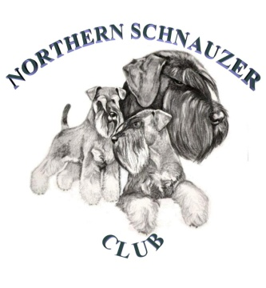
NORTHERN SCHNAUZER CLUB
President:- Mr H Marshall Chairperson:- Mrs K Bradbury-Hall
Hon Secretary:
Miss C M Ellingworth, 20 Harworth Avenue, Blyth,
Worksop, Nottinghamshire, S81 8HH
Tel: 01909 384214
Email: doncleve@me.com
20th March 2023
Dear Member/s

The Annual General Meeting of the Northern Schnauzer Club will take place on Sunday 16th April 2023 at 10am @ Haddlesey Village Hall, Mill Field Road, Chapel Haddlesey, Selby, YO8 8QF

Coffee & tea available from 09.30. The agenda for the meeting is printed below.

Yours sincerely

Chris M Ellingworth

Chris Ellingworth
Hon Secretary

ONLY FULLY PAID UP MEMBERS MAY ATTEND.

AGENDA

1. Apologies for Absence.
2. Approve the Minutes for 2022 A.G.M.
3. Matters Arising.
4. To receive the Chairman's Report.
5. To receive the Hon. Secretary's Report.
6. To receive the Hon. Treasurer's Report.
7. To approve the accounts for 2022.
8. To appoint Auditors for 2023
- Mr B Hill - proposed K Bradbury-Hall and seconded by Mr A Herdman
9. Secretary's & Treasurer's Honoraria.
10. To declare the members elected to serve as Officers & Committee members.

Election of Officers:

- Treasurer: Mr Anthony Herdman - Proposed K Fish, Seconded M Cockerham
Election of Committee:

- H Smith has confirmed that she is retiring & offering herself for re-election.

Dated: 20th March 2023

