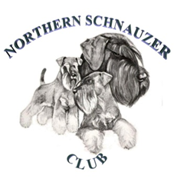
Application to be on the Northern Schnauzer Club Groomers List

By completing this application, you agree to your location in the United Kingdom/Northern Ireland being shared in various ways by the club.

Applications will only be considered if you are a fully paid-up member of the club.
If you wish to become a member, then please email fishjanice@hotmail.co.uk

Name:

Address (Your general location will be used to advertise your services):

Telephone number:

Any special services offered (Mobile/pick up & drop off etc)?

Please return the completed form to: kfish2007@hotmail.co.uk

