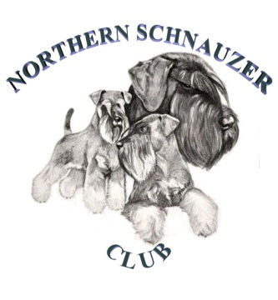
Northern Schnauzer Club Championship Show Saturday 13th November 2021

Elsecar Heritage Centre, Wath Road, Elsecar, Barnsley, S74 8HJ

- ONE FORM TO BE COMPLETED FOR EVERY VEHICLE ENTERING THE SHOWGROUND
- EVERY PERSON IN THE VEHICLE MUST BE LISTED
- TO AVOID DELAY PRE-COMPLETE YOUR FORM, READY TO HAND IN TO YOUR CAR PARK MARSHALL
- ANYONE NOT NAMED ON THE FORM WILL NOT BE PERMITTED TO ENTER THE SHOW
- PLEASE NOTE: EXHIBITORS & VISITORS- NO ENTRY TO THE VENUE BEFORE 9.00AM

NAME | CONTACT NUMBER | EMAIL

As requested by NHS Track and Trace these forms are kept for 21 days following the event, and then destroyed

We would recommend that MASKS BE WORN in close contact situations and
1 metre SOCIAL DISTANCING BE MAINTAINED

