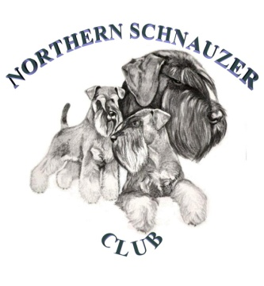
Northern Schnauzer Club General Data Protection Act (GDPA) Retention Policy

Introduction

“Data minimisation” is one of the overarching principles in the GDP Regulation (GDPA). It requires personal data to be retained only for so long as is necessary. Personal data should therefore only be kept as long as is strictly necessary and this policy defines those time limits OR the criteria to determine when data should be disposed/deleted securely.

Retention Policy Template

The Northern Schnauzer Club will only retain personal data for as long as necessary to fulfil the purposes for which it was collected including for the purposes of satisfying any legal, accounting, or reporting requirements.

Personal data can be further processed and stored for archiving in the public interest and statistical and historical research purposes. When doing so we will consider:

- Any link to the initial purpose
- The context the data was collected in
- The reasonable expectations of members/exhibitors/competitors/judges
- The nature of the data
- The consequences of further processing and the existence of appropriate safeguards
- Whether such data can be ‘anonymised’ if being preserved for archives.

Financial Records

There is a statutory requirement to keep financial records for seven years. However, records may be kept for the last eight years, in order to ensure that year-ends are available. Beyond the eight-year point, there is little justification in keeping bank statements, cheque stubs etc. unless there was an incident, which was of particular significance.

Membership Lists

Old membership lists may have some historical value and / or statistical
value The Northern Schnauzer Club will consider how long is practically useful.

Constitutions

Out of date constitutions come into the same category. Whilst details of changes will be included in AGM reports, there may be a historical interest in retaining original versions where possible, and which can be displayed as part of commemorative exhibitions.

Show Catalogues and Show Entry Forms

Show catalogues can provide a gold mine of information and statistics, as well as forming an important historical record. Show entry forms must be retained for twelve months after the show.

Committee and Annual General Meetings (AGM) / Special General Meetings (SGM) Minutes and Documents

Committee minutes and documents relating to AGMs and SGMs must be retained as the definitive record of all club business together with the decisions made and policies agreed. They are also an information resource to resolve any procedural issues or disputes.

NSC/Ret/Policy VS 1 MAY 2018

