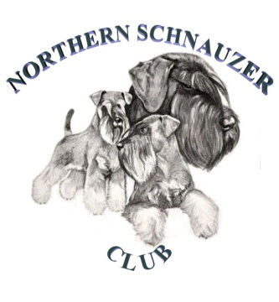

NORTHERN SCHNAUZER CLUB

Hon. Secretary: Miss C M Ellingworth

20 Harworth Avenue

Blyth, Worksop

Notts

S81 8HH

Tel. 01909 591291 Email. doncleve@me.com

MEMBERSHIP NEW / RENEWAL APPLICATION FORM
Memberships are from January 1st to 31st December and renewable annually.
MEMBERSHIP RENEWAL DATE – 1ST JANUARY EACH YEAR
Please delete which is NOT applicable

- I / WE wish to apply for Membership of the Northern Schnauzer Club (NSC)
- I / WE wish to renew my / our Annual Subscription
- I / WE will abide by the club rules and regulations at all times and will abide by the club’s code of ethics

The Officers and Committee of the NSC reserve the right to accept or reject any proposal for membership.

SIGNATURE/S (for joint membership - both to sign please):

1. 2.

DATE:

Please note by providing us with your information we imply that you consent for your details to be kept electronically and or hard copy for contact by the club only. Your information will not be passed on to third parties. For further details you can visit our website. www.northernschnauzerclub.co.uk

BLOCK LETTERS PLEASE:

NAME: (Mr/Mrs/Miss/Ms)
ADDRESS:

POSTCODE: Tel: Email:
Please complete your email address for communication purposes only

BREEDS OWNED: MINIATURE / SCHNAUZER / GIANT (delete which is not applicable)

MEMBERSHIP FEE ENCLOSED: SINGLE £7.00 / JOINT £10.00 / JUNIOR £2.00
PROPOSED BY: SECONDED BY:
Cheque / postal orders payable to; - NORTHERN SCHNAUZER CLUB
Please return this form & membership fee to: -

NSC Membership

Mrs Janice Fish
30, Prospect Drive,
MATLOCK.
Derbyshire.
DE4 3TA

EMAIL: - fishjanice@hotmail.co.uk

